Results and Discussion

In this section, I will elaborate (1) details of how I implement this project, (2) what results did I find during the implementations, and (3) what conclusions could I get from the results.

Dataset Preprocessing

In the petroleum production field, production data are recorded as time series data, as the format of rate versus month, precisely speaking. The data used in this project were extracted from DrillingInfo (DrillingInfo 2017), which is an official website specifically focusing on providing nation-wide oil and gas production data. I picked up 200 gas wells from Barnett Shale reservoir that are active in production. Picking up production wells from the Barnett Shale ensures that those wells are from the same geologic area.

The 200 wells have different starting production time in month, but share the same ending production time in May 2017, which results in the different feature length for them. Our first step is to label those 200 samples. For each well in the field, there is a typical production profile as shown in the figure 1. The data in figure 1 are from one of the 200 wells we will be using during this project. The red dots showed the trend of declining rate of production. With the time increasing, the production rate will decrease below a threshold, which is called “abandon rate”. Normally speaking, the life of one particular unconventional gas well should last for over 360 months before it decreased to its abandon rate. This gives us a clue to label the 200 wells. We label the wells by separating them into different type according to the P10, P50 and P90 values.

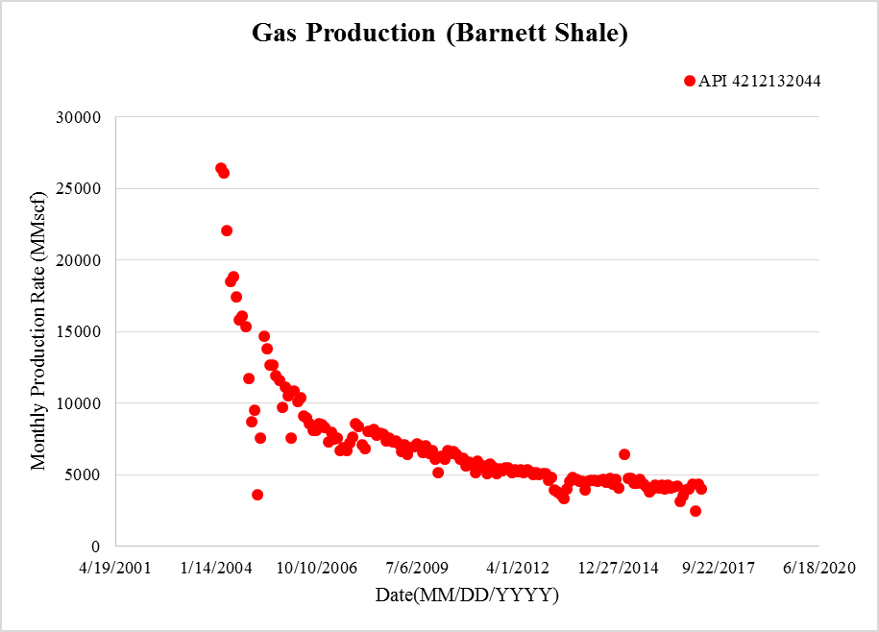

Figure 1 Typical Well Production Profile

Forecasting

As we see from the figure 1, we have only limited data points (i.e. less than 360 months). For the sake of reliably labelling the available dataset, we used some mathematical models developed by researchers earlier in petroleum industry to implement the forecasting process. The forecasted data will be assumed as the ultimate estimate recovery (EUR), which will be further used in the labelling stage.

Power’s Law (Ilk, Rushing et al. 2008)

Where:

is the decline constant “intercept” at 1 time unit, 1/days

is the decline constant at infinite time, 1/days

is the time exponent, unitless

is the rate intercept bbl/day or Mcf/day

Stretched Exponential (Valko and Lee 2010)

Where:

is the production rate at any time

production rate at time = 0

is the characteristic time parameter

is the time exponent, unitless

Duong’s method (Duong, 2011)

Where:

is the cumulative production

is the production rate, vol/day

is the time, days

& are constants

Since we are dealing with type wells, we need to ensure that all the wells that we used to construct type wells have reached the boundary dominant flow (BDF). The reason is that before wells reach BDF, well production exhibit transient flow and it’s nearly impossible to forecast a well’s EUR given only transient flow data. The two examples of wells that do not exactly reach the boundary dominant flow are shown in figure 2. The two wells are selected from the 200 wells that we are going to use in this project.

In these two log-log plots, the blue lines show the raw data plotted in log-log scale. It is quite obvious that the slope of the decline trend line is 0.5 by the end of May 2017, which is indicated by the green line. This means that the two wells have not reach the BDF, which is specifically indicated by the red lines. In this way, I cannot use the data and the 3 models mentioned above to implement the forecasting directly.

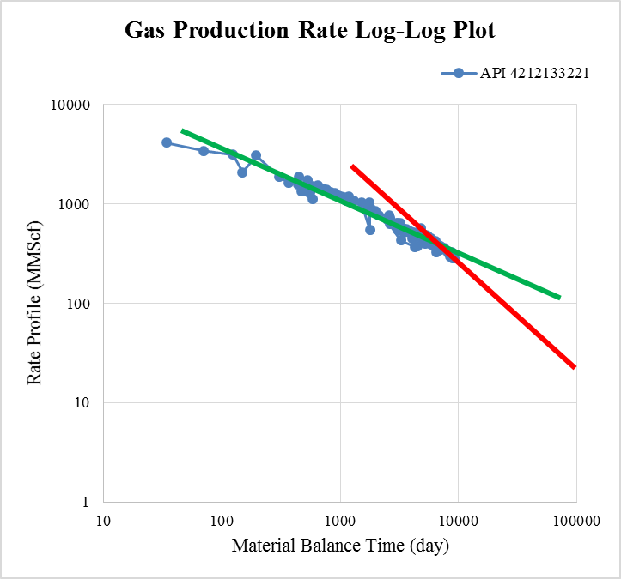 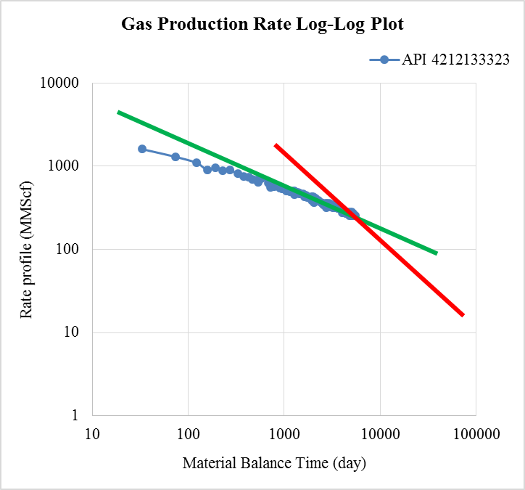

Figure 2 Wells Not Reaching Boundary Dominant Flow

To resolve this problem, we implement the forecasting by implement extrapolation through specifying the switch point. In the software ValNav (ValNav 2017), we have three options to specify the switch point from linear flow to BDF: specifying the fixed decline slope (%/yr), specifying months after the start of first declining forecast segment, and specifying the months after start of history. Here we choose to specify the switch point by specifying the fixed decline slope (%/yr) at 6.5 as shown in figure 3.

After this setting, ValNav will automatically transfer into BDF mode after the decline rate (%/yr) of transient flow is identified. In this way, when it is implementing the forecasting, the production histories will be extended to 360 months, and thus we can make sure the 200 wells have reached the BDF by the end of the 360 months. This resolves the problem.

When using the software ValNav to predict the future production, we can easily choose the best fit from the three models for each well to do the forecasting. Figure 4 and figure 5 gave the GUI interface for the ValNav and BestFit, respectively. The BestFit automatically selects the most recent data and the most suitable model to fit data first and will implement the forecasting based on the selected data and model. The ValNav sometimes may give us data more than 360 months (E.g. when we only specify the abandon rate at 10 Mscf/d as we have done in this project), but we only use the 360 months data.

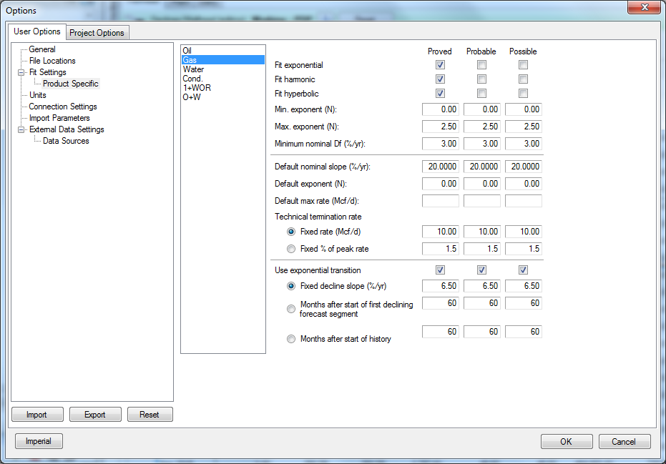

Figure 3 Specifying the Switch Point in ValNav

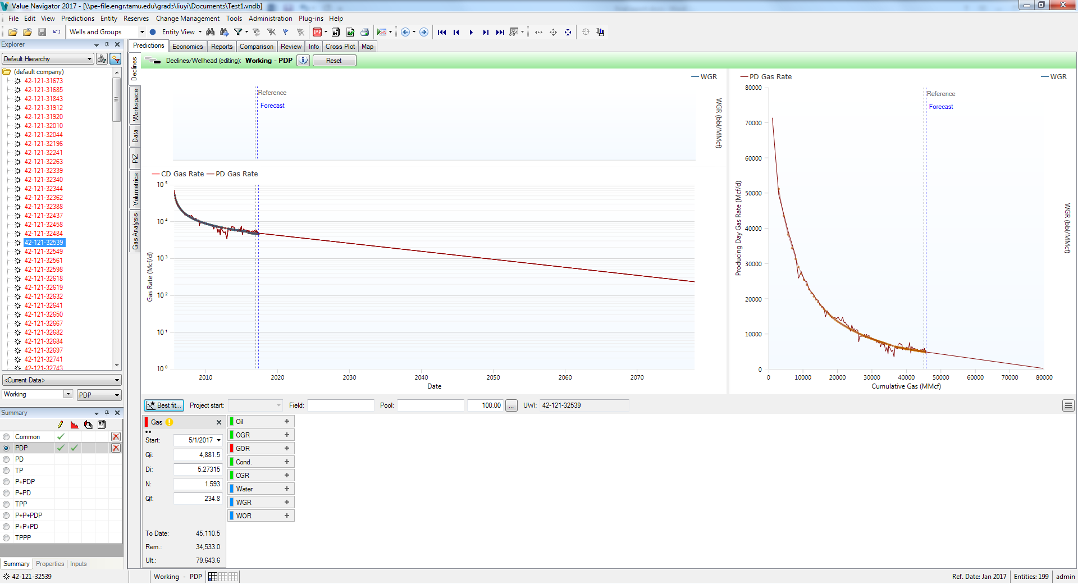

Figure 4 ValNav Interface

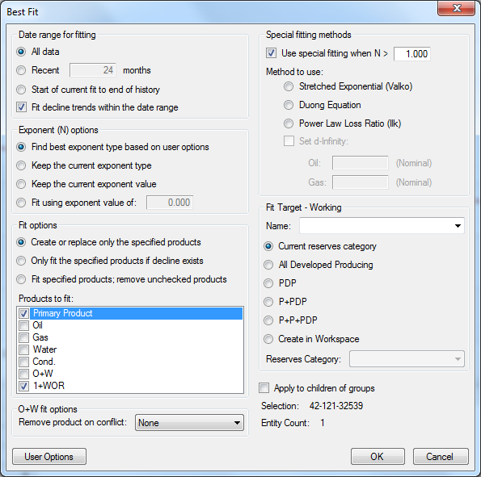

Figure 5 Best Fit Interface in ValNav

After ValNav has completed the BestFit procedure, a typical production profile is shown in figure 4. The profile, as mentioned before, has a production life more than 360 months. However, we only need the first 360 months’ data. The EUR of each well is then thought to be the cumulative production at the end of 360 months.

LogNormal Distribution of EUR

With 200 EUR values given, I sort them in descending order accordingly. In this case, each EUR value for each well is corresponding to a “less than probability”. I plotted the EUR distribution in a log probability paper as shown in figure 6. The horizontal and vertical axis of figure 6 are EUR values, and “less than probability”, respectively, both in logarithmic scale. The majority of the EUR values are approximately located on a straight line, indicating a lognormal distribution of EUR values of wells from this geologic area.

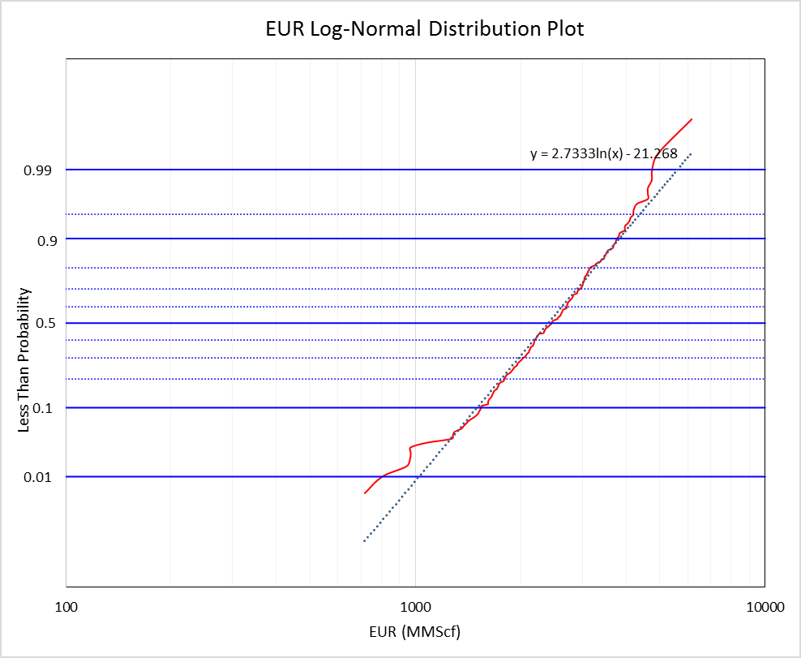

Figure 6 EUR lognormal distribution

Type well construction and evaluation

Given that EUR is predicted by ValNav as shown in figure 6, this step focuses on constructing type wells. With the insurance of BDF and the EUR value for each well, I can simply find the P90, P50, and P10 type wells, which are 1538.053 MMscf, 2448.201 MMscf, and 3759.201, respectively. The P90 value is the EUR value corresponding to the less than probability of 0.1 in figure 6, and P50 and P10 corresponds to 0.5 and 0.9 respectively. From this, we can get the P10/P90 ratio at approximately 2.324, indicating a low distribution variance, which in turn manifest a low uncertainty in the distribution.

The minimal dispersion in this problem indicates a good probabilistic property of the type wells, which means that the type wells (P90 and P10) constructed can be a sound representative of wells in this geologic area. This is critical for us to reliably apply the type wells data generated in this step to our further usage.

Labelling

With the aid from ValNav, we have got the EUR for each well and 360 months’ production data. For further application, we label the 200 data in this section. The labels given to each well sample are called types. The types are classified according to their corresponding EUR which is the last value on the red dotted line in figure 1. With 200 estimate ultimate recovery values given, we sort them accordingly. In this case, each estimate recovery value for each well is corresponding to a “less than probability”. Since the estimate ultimate recovery is in log normal distribution, so I plotted the EUR distribution in a lognormal paper as shown in figure 4.

Problem comes to how to divide the samples into different types. In this project, I separated the well samples into 4 types. This separation schema is commonly employed in petroleum literatures. Ba careful that P10, P50 and P90 values are referring to greater than values, which is intuitively contrary to less than probabilities shown in the plot in figure 4.

Type1 - Above P90, the P90 corresponding EUR is 48062.86016 in figure 4, probability 0.1

Type 2 – P50 – P90, the P50 corresponding EUR is 74265.31784 in figure 4, probability 0.5

Type 3 – P10 – P50, the P10 corresponding EUR is 115750.2296 in figure 4, probability 0.9

Type 4 – Below P10, the largest EUR is 192576.9152 in figure 4, highest point in the graph

After the type wells in a particular geologic area are constructed, they are claimed to be representative enough with a certain confidence. We train the rest data to fit them into one of those type wells. We will choose artificial neural network and support vector machine are our primary training methods to classify newly drilled wells with limited production history into one of our types.

Machine Learning Algorithms

The machine learning algorithms I used include neural networks (NNet), support vector machine (SVM) and Random Forest (RF), each has its pros and cons. I used 4-fold cross validation to reduce the probabilities of overfitting. All the algorithms are implemented using python.

NNet

The advantage of neural networks over other machine learning algorithms is that neural networks can deal with any nonlinear relationships among various variables. In addition, we don’t need to consider the dependence between each pair of variables, the number of parameters and hyper-parameters. The backpropagation algorithm is the core of the neural network algorithm. Figure 1 illustrates the back propagation algorithm schematically. It is based on a stochastic gradient descent algorithm. After wells have been trained, it will then be appropriate to classify the test wells. In the training process, neural network performance can be improved by using various techniques such as cross validation.



Figure 8 Neural Network Backpropagation Algorithm

SVM

SVM is one of the most classical machine learning algorithm. Its primary objective is to find a plane that can separate the samples with largest margin, i.e. maximize the margin. As we are dealing with the non-separable samples, we would expect some misclassified samples. Those misclassified samples need to be taken into considerations while the algorithm searching for the optimal hyperplane. In this case, we constructed the Lagrange primal function with a C coefficient. In either case (separable or non-separable case), we need to deal with a Lagrange dual function with a KKT condition, which serves as the mathematical theory for this algorithm.

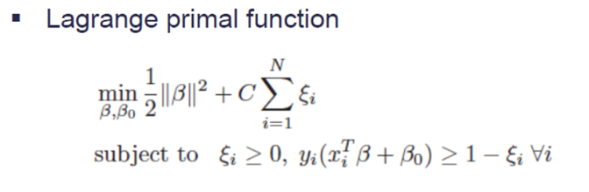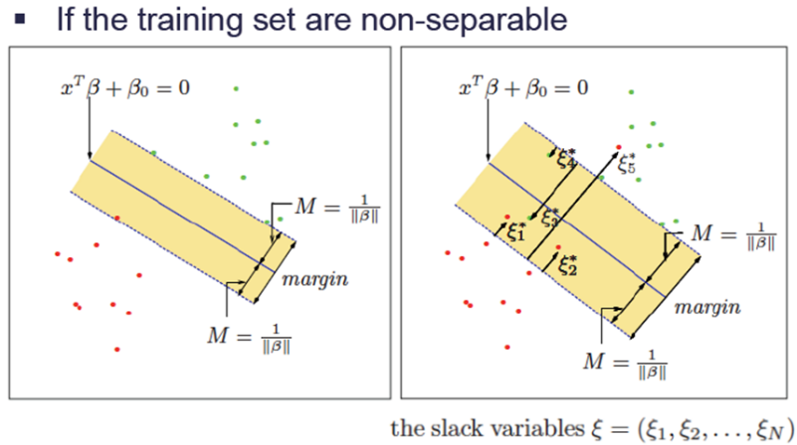

Figure 9 Basic Principles of Support Vector Machines

RF

RF is an ensemble approach that adopted divide-and-conquer idea to improve performance. The main principle behind RF is that a group of “weak learners” can come together to form a “strong learner”. It can both be used in classification and regression problems (CART). RF starts with a standard machine learning technique called “decision tree” which, in ensemble terms, corresponds to the weak learner. In classification problem, we use the Gini index as the criteria to split the nodes.

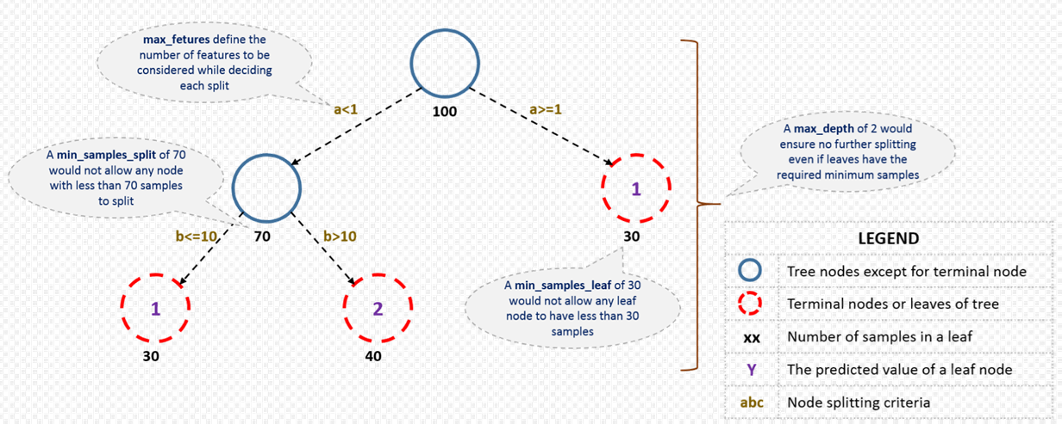

Figure 10 Structure Terms of Random Forest

The other major objective of this project is to apply the type wells to forecast the EUR of new wells with only relatively short production history. In terms of the specific application, I proposed to use the machine learning algorithms to classify the new wells into one of the 4 types, i.e. type 1🡪EUR below P90; type 2🡪EUR between P50 and P90; type 3🡪EUR between P10 and P50; type 4🡪EUR above P10.

For example, as we have a new well with short history, after the classification, this well may be classified into type 1, then I can claim that I have over 90% confidence to have EUR larger than P90 from that specific well; if that well is classified into type 4, I have only less than 10% confidence to have EUR larger than P10 from that specific well. The gives the importance of the type well in reserve evaluation and financial decision making for oil and gas companies.

We successfully applied 3 machine learning algorithms to classify the wells with only short production histories, including neural networks (NNet), support vector machine (SVM) and random forest (RF). The generalization error was reduced using cross validation technique.

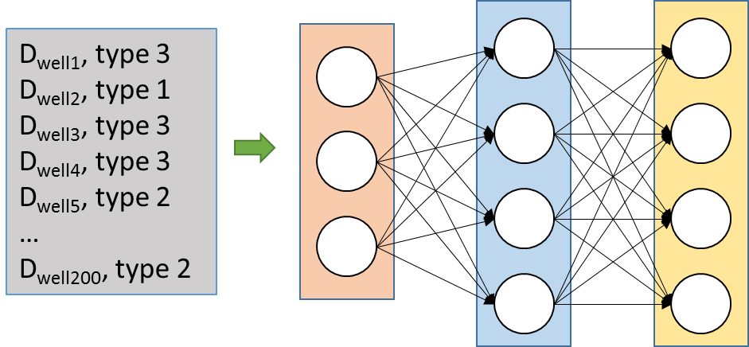

Figure 11 Neural Networks Training Schema

Figure 2 shows the general NNet training schema architecture used in our problem. There is only 1 hidden layer in the architecture. The number of the input layer neurons, hidden layer neurons, and output layer neurons are 170, 100, and 4, respectively. The classical logistic function was employed as forward activation function. In the backpropagation process, the weights are updated using lbgfs solver, which is one of the quasi-newton option. In addition, the learning rate and momentum parameters were set to be 0.1 and 0.5, respectively, to improve the overall performance of this architecture.

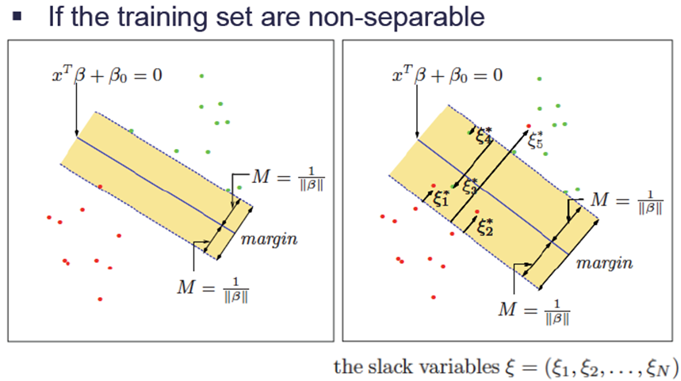

Figure 12 Support Vector Machine - hard margin and soft margin

In our specific problem, it is hard to find the optimal separating plane with hard margin that can perfectly separate all data samples into the group in which they should be, so we adopted the soft margin for the SVM algorithm to resolve our non-separable problem. This was indicated by the fact that the C value was set to be 1.0. An advantage of SVM is that it can use kernel method to transform the available data onto another space for better classification effect. However, in this problem, the simple “linear” kernel works best, which means that we do not need to transform the data onto other space. This may be due to the fact that the labels (i.e. types) of all wells in our problem were generated based on EUR values, and the EUR values, in turn, were calculated through linear combination of monthly production rate. Additionally, the stopping criteria (i.e. error tolerance) was set to be 1e-3.

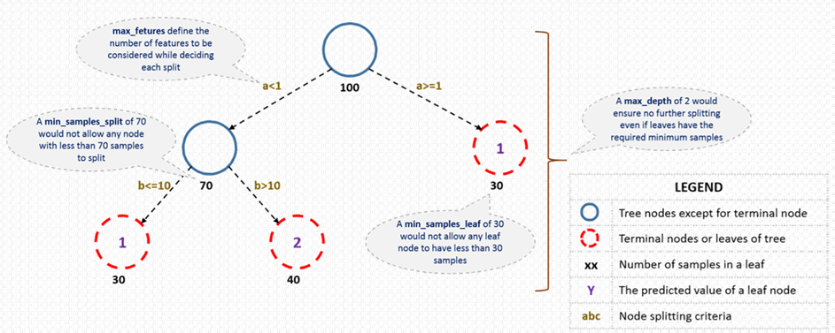

Figure 13 Random Forest Terms

RF is an ensemble approach that adopted divide-and-conquer idea to improve performance. The main principle behind RF is that a group of “weak learners” can come together to form a “strong learner”. It can both be used in classification and regression problems (CART). RF starts with a standard machine learning technique called “decision tree” which, in ensemble terms, corresponds to the weak learner. In classification problem, we use the Gini index as the criteria to split the nodes. The number of decision trees, the maximum tree depth and maximum feature are set to be 100, 20 and 50, respectively.

1. The classification results were shown in figure 5.

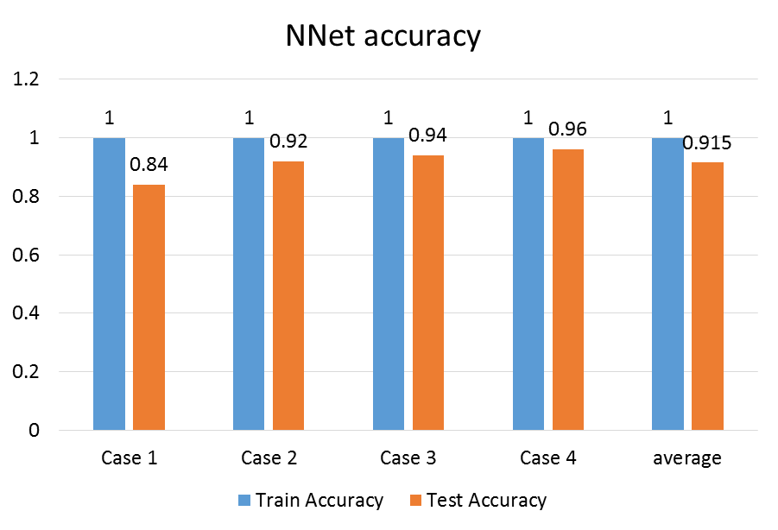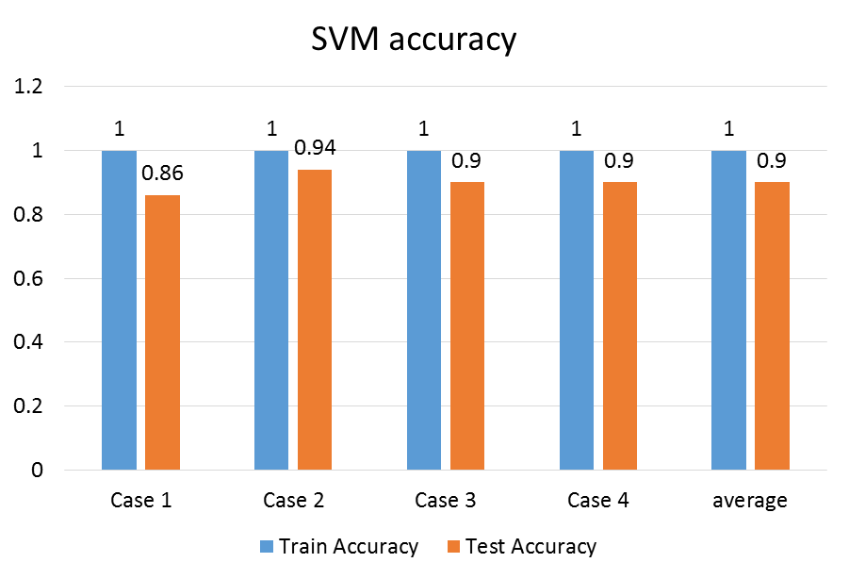

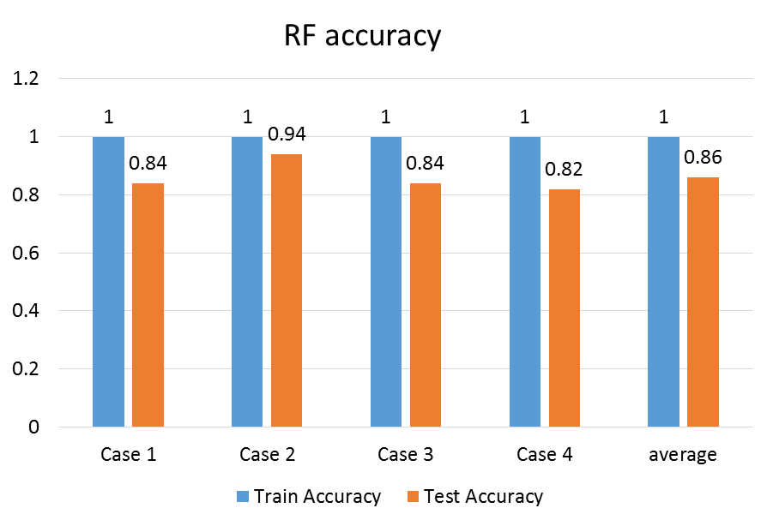

Figure 14 Machine learning algorithm application results

As shown in figure 5, the 3 machine learning algorithms can achieve 100% training accuracy in classifying the wells with only limited production history. The test accuracy ranged from 0.82 to 0.96. The neural networks provided the best average accuracy among the 3 algorithms.

Reference

DrillingInfo 2017 <https://info.drillinginfo.com>

D. IIK, J.A. Rushing, A.D. Perego, T.A. Blasingame, Exponential vs. Hyperbolic decline in tight gas sands: understanding the origin and implications for reserve estimate using Arp’s decline curves, Presented at the SPE Annual Technical Conference and Exhibition, 21-24 September (2008, January 1), 10.2118/116731-MS, Denver, Colorado, USA

Valko, P. P., & Lee, W. J. (2010, January 1). A Better Way To Forecast Production From Unconventional Gas Wells. Society of Petroleum Engineers. doi:10.2118/134231-MS

A.N. Duong, 2011, Rate-decline analysis for fracture-dominated shale reservoirs, SPE Reserves Evaluation Engineering, 14(03) (2011), pp.377-387, 10.2118/137748-PA

ValNav 2017 <http://www.energynavigator.com/value-navigator>